Can I use Silicon Labs Driver
on old version of Windows 10 to run UMViewer?

Windows 10 old version are versions before 1803 ver.

How to download Silicon Labs for old version of Windows 10:
1. Open " UmViewer" folder
2. Open "Install" folder
3. Open "Driver" folder
4. Open"_10" folder
5. Open "CP210x_VCP_Windows" folder
6. a) If your computer is 64-bit operating system, please install "CP210xVCPInstaller_x64"
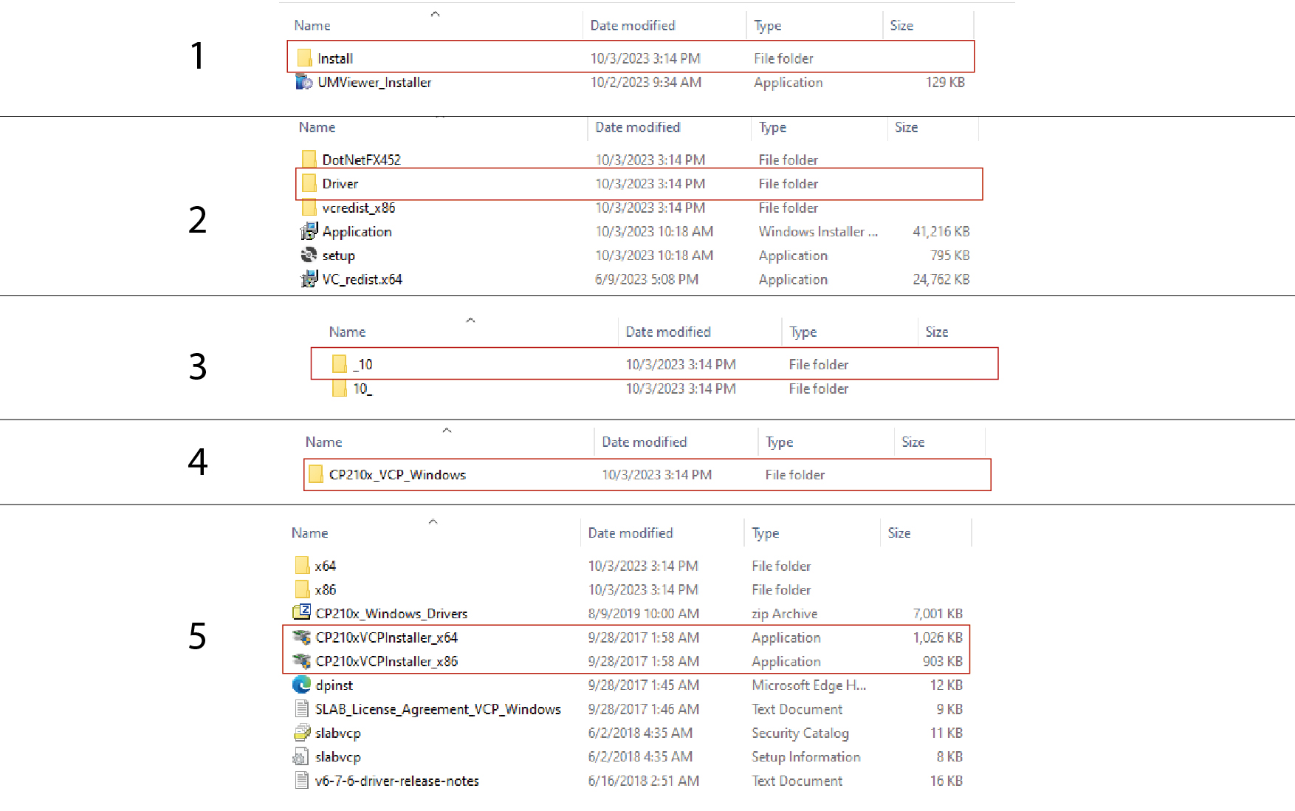
b) If your computer is 32-bit operating system, please install "CP210xVCPInstaller_x86"

